Mrs. Morgan’s  Student  News |  | 

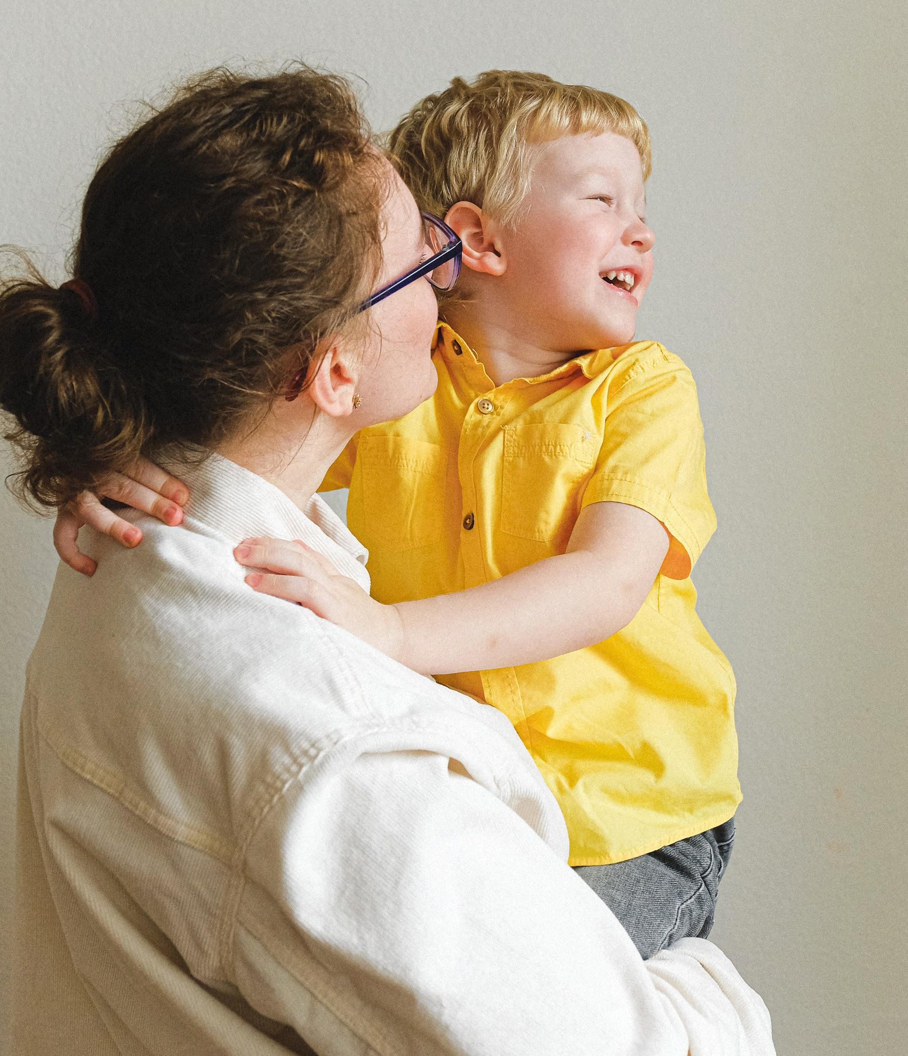 | News for the week of: January 5, 2026  Reading: 20 minutes per night  Multiplication facts: practice 5 minutes each night  Spelling words (turkey, lonely, galley, steady, hungry, valley, hockey, starry, melody, movie, duty, drowsy, chimney, plenty, daily, alley, fifty, empty, injury, prairie)  Vocabulary:(display, huddle, concluded, fractured, alert, standards, vision, stranded, weariness, graceful)  y
WI
 | Content Standards for the Week:  READING: Antartica Journal  (SKILLS): Figurative Language (Personification)  MATH: Fractions (Adding)
 | Other Communication:  January  (6) Start of 3rd Quarter  (8) Spirit Day (bring $1 and a can)  (16) Field Trip to Aviation Museum  (19) No School  (23) Virtue Awards  (26-30) Catholic School’s Week

